Total Data in temperature_data

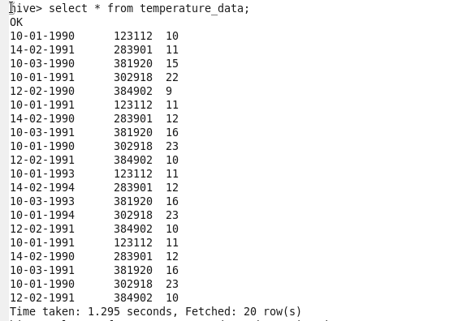

Problem

1)Fetch date and temperature from temperature_data where zip code is greater than

300000 and less than 399999

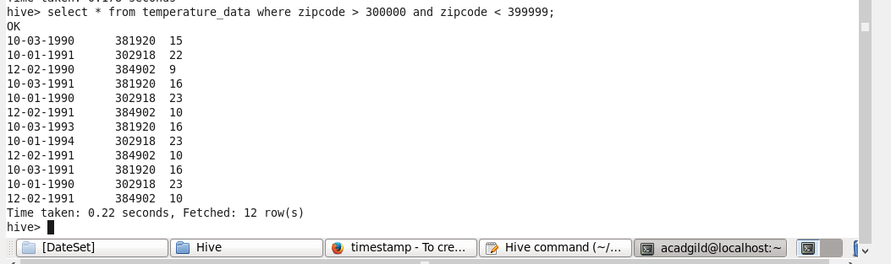

2) Calculate maximum temperature corresponding to every year from temperature_data

Table.



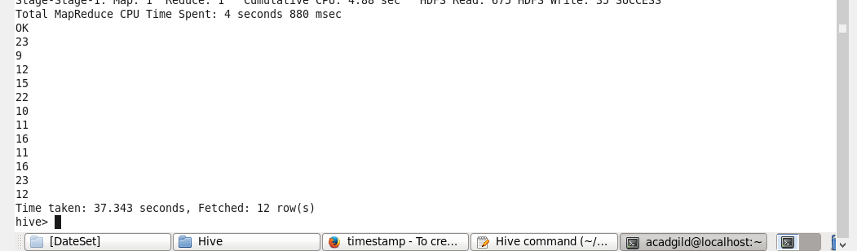

3) Calculate maximum temperature from temperature_data table corresponding to those

years which have at least 2 entries in the table.

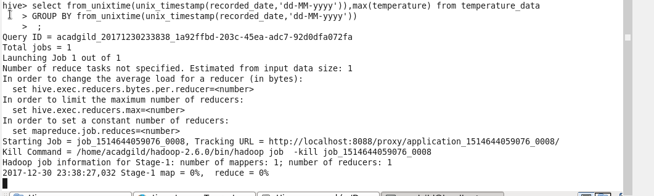

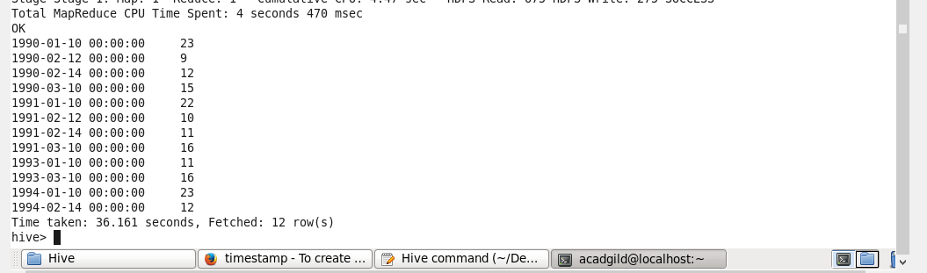

4) Create a view on the top of last query, name it temperature_data_vw.

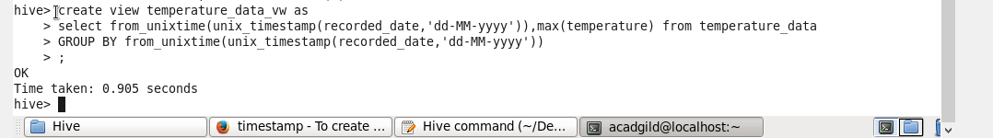



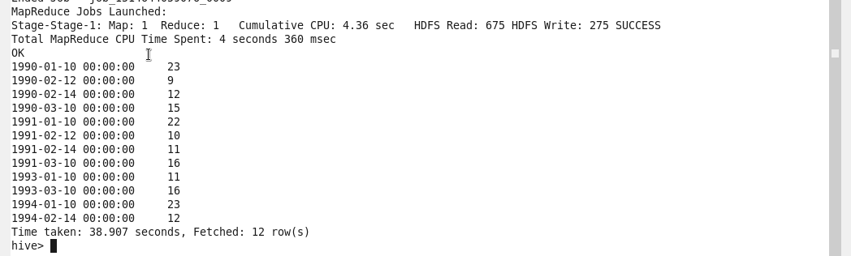

5) Export contents from temperature_data_vw to a file in local file system, such that each

file is '|' delimited.



